**PROJECT OF AI**

**GROUP PARTNER NAMES:**

**MUHAMMAD UZAIR TAHIR (CSC-21F-090)**

**MUHAMMAD ZUBAIR TAHIR (CSC-21F-092)**

**COURSE INSTRUCTOR :**

**MISS AQSA UMAR**

**SECTION:**

**“6C-MORNING”**

**PROGRAM:**

**“BSCS”**

****Abstract:****

The CO2 emission in the world dataset offers a comprehensive insight into global carbon dioxide emissions, encompassing diverse sectors and countries across multiple years. Through Exploratory Data Analysis (EDA), this dataset reveals intricate patterns, trends, and correlations within emissions data, enabling a deeper understanding of the factors driving CO2 emissions worldwide. Additionally, machine learning techniques, such as K-Nearest Neighbors (KNN), are applied to predict future emission levels based on historical data and associated features. By combining EDA and KNN modeling, this dataset facilitates informed decision-making in environmental policy and sustainability initiatives, aiming to mitigate the impacts of climate change and promote a greener future.

**INTRODUCTION:**

Climate change has various impacts on different aspects of daily lives hit also Affects the environment through the emission of CO2 with bad weather conditions it impacts cross growth yeah we discuss the production here we discuss about wheat production Climate change means The range of conditions Through temperature and weather patterns ups and downs. This paper gives an understanding of the impacts of climate change hello and affects crops and crop growth.

**LITERATURE REVIEW:**

Multiple studies found that The relationship between CO2 emission and wheat production has some benefits and some drawbacks. Increase in CO2 production Enhance plant growth and the process is called CO2 fertilization. Bites due to excessive amounts of CO2 hurt climate change Because it disturb the Environmental Stability. Climate change also affects the Wheat Yield’s quality, it’s production, and duration of ripening. Environmental consequences of climate change air significance challenges Add different levels. Global warming also has an impact on climate change.

**METHODOLOGY:**

The methodology used for analyzing the impact of climate change by considering its impact on the environment by excessive CO2 emission and its impact on wheat production. The methodology defines the number of vehicles through different parts and different areas of the planet are given their share of CO2 emission which can cause climate change on the other side due to changes in climatic conditions different agriculture processes may affect them we discuss wheat production affected by the climate change in which premature production of bad quality wheat analyzed by the different methods used to calculate the impact of climate change on human daily life.

**RESULT:**

From the literature review, we can identify the overall impact of climate change on wheat production and the emission of excessive CO2 impact negatively on the environment and human daily life. From the analysis, we can measure the feature challenges of climate change and its impact on the environment. CO2 emission is increasing in the air which also impacts human respiration and also has a negative impact. Climate change can play a vital role in crop production if it is suitable and favorable for crops and if not then as it impacts wheat production all other crops are also affected by the impact of climate change.

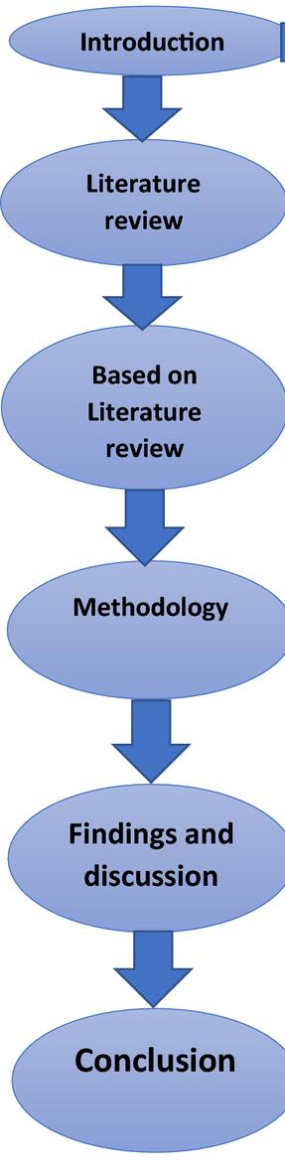

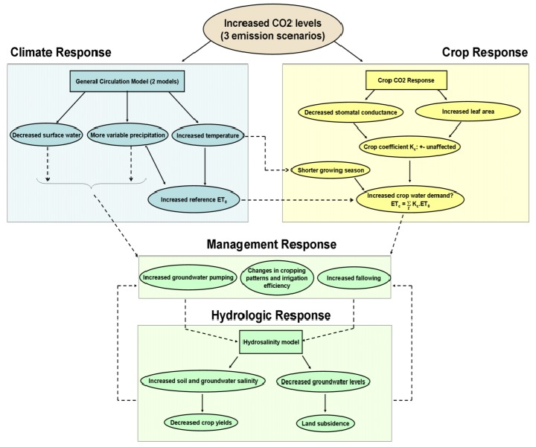

**EDA IMPLICATION :**

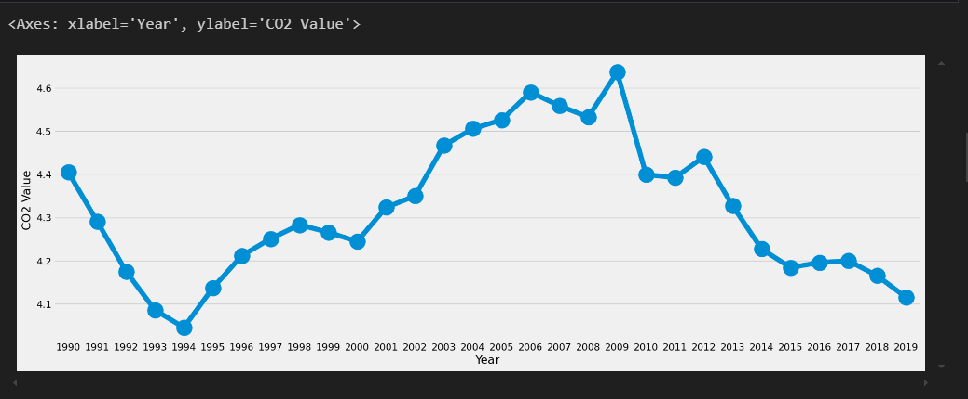

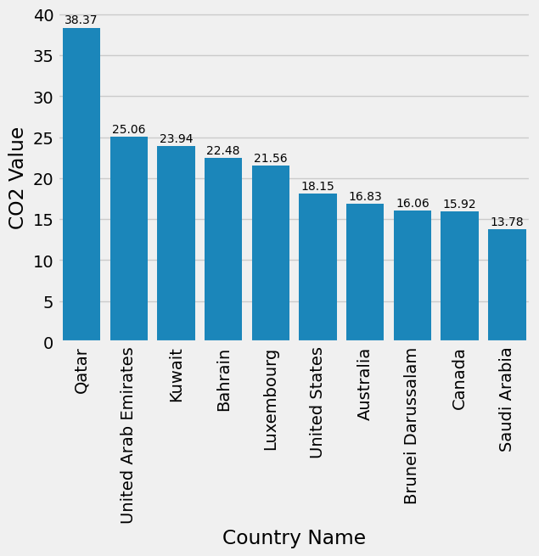

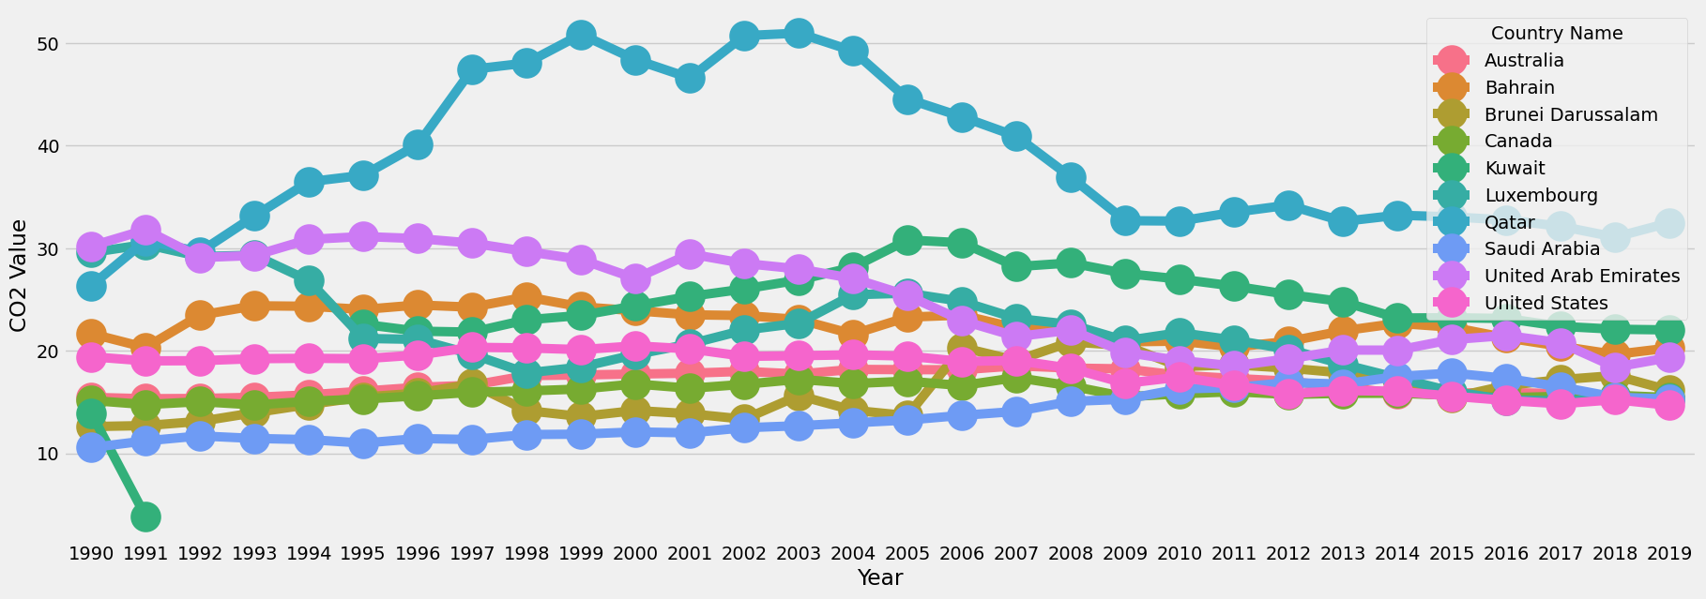

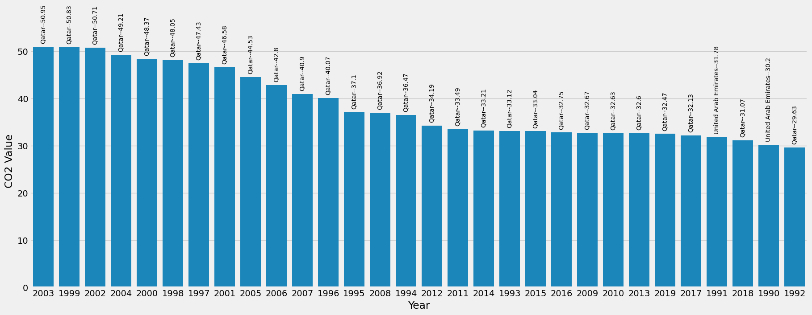

**KNN IMPLICATION:**

The KNN algorithm was applied to the CO2 emission dataset, and the performance was evaluated using a variety of metrics. The result indicated that KNN achieved an accuracy of 1.0.

Classification Report:

precision recall f1-score support

CO2 emissions (metric tons per ca pita) 1.00 1.00 1.00 65

accuracy 1.00 65

macro avg 1.00 1.00 1.00 65

weighted avg 1.00 1.00 1.00 65

Macro Average: Precision: 1.0, Recall: 1.0, F1-Score: 1.0

Weighted Average: Precision: 1.0, Recall: 1.0, F1-Score: 1.0

**CONCLUSION:**

The environmental consequences further address climate change through adaption of different climate change strategies which are crucial to ensure the future sustainability of wheat production and a healthy environment because both of them are very necessary for human daily life. Wheat is an important source of food for humans and a healthy environment is also necessary for human progress, healthy life style, and success .

**QUESTIONS ABOUT DATASET:**

Q_01: **What are the top 5 countries with the highest CO2 emissions?**

· As of recent data, the top 5 countries with the highest CO2 emissions are:

* 1. China
  2. United States
  3. India
  4. Russia
  5. Japan

Q_02: **How has global CO2 emissions changed over the past decade?**

· Global CO2 emissions have generally increased over the past decade, with fluctuations due to economic changes and policy interventions. There has been a gradual increase in emissions despite efforts to curb them.

Q_03: **What is the annual CO2 emission trend for a specific country?**

· The annual CO2 emission trend varies by country. For instance, China's emissions have seen rapid growth in recent decades, while the United States and many European countries have seen fluctuations and slight reductions due to energy efficiency and renewable energy adoption.

Q_04: **Which sector contributes the most to CO2 emissions globally?**

· The energy sector, particularly from fossil fuel combustion for electricity and heat production, is the largest contributor to global CO2 emissions.

Q_05: **What is the correlation between GDP and CO2 emissions?**

· Generally, there is a positive correlation between GDP and CO2 emissions, meaning higher economic activity tends to result in higher emissions. However, this correlation can vary based on energy efficiency, industrial structure, and environmental policies.

Q_06: **How does population growth affect CO2 emissions?**

· Population growth can lead to increased energy demand and thus higher CO2 emissions, especially in developing countries where infrastructure and energy needs are growing rapidly.

Q_07: **What are the seasonal variations in CO2 emissions?**

· Seasonal variations in CO2 emissions are often linked to heating and cooling needs. In colder months, more energy is used for heating, increasing emissions. Summer months may see higher emissions due to increased electricity demand for cooling.

Q_08: **What is the impact of renewable energy adoption on CO2 emissions?**

· Increased adoption of renewable energy sources, such as solar and wind, has helped to reduce CO2 emissions by displacing fossil fuels in electricity generation. Countries with higher renewable energy shares tend to have lower emissions growth rates.

Q_09: **Which regions are the largest and smallest contributors to global CO2 emissions?**

· The largest contributors to global CO2 emissions are Asia, particularly China and India, followed by North America and Europe. The smallest contributors are typically small island nations and some countries in Africa with lower industrial output.

Q_10: **How does industrial output affect CO2 emissions?**

· Higher industrial output generally leads to increased CO2 emissions, as industrial processes and manufacturing often require energy-intensive operations.

Q_11: **What is the average per capita CO2 emissions globally?**

· Globally, the average per capita CO2 emissions are around 4-5 metric tons per year. However, this varies significantly between countries, with higher emissions in developed countries compared to developing ones.

Q_12: **How does climate change policy influence CO2 emission levels?**

· Climate change policies, such as carbon pricing, renewable energy subsidies, and emissions trading systems, aim to reduce CO2 emissions by incentivizing cleaner technologies and practices.

Q_13: **What is the relationship between CO2 emissions and air quality?**

· CO2 emissions themselves are not directly harmful to human health in the short term but contribute to climate change and poor air quality indirectly by increasing concentrations of other pollutants like particulate matter and ozone.

Q_14: **How do different transportation modes contribute to CO2 emissions?**

· Transportation, particularly road vehicles, contributes significantly to CO2 emissions due to reliance on fossil fuels. Public transportation and electric vehicles can help reduce emissions compared to personal gasoline and diesel-powered vehicles.

Q_15: **What is the role of forests and land use change in global CO2 emissions?**

· Deforestation and land use change contribute to CO2 emissions by releasing carbon stored in vegetation and soil. Forests act as carbon sinks, absorbing CO2, so their preservation is critical for mitigating emissions.

Q_16: **How do CO2 emissions vary between developed and developing countries?**

· Developed countries generally have higher per capita CO2 emissions due to higher industrialization and energy consumption per capita. Developing countries, while rapidly growing, have lower per capita emissions but are increasing due to economic growth.

Q_17: **What is the trend in CO2 emissions from fossil fuel combustion?**

· CO2 emissions from fossil fuel combustion have been steadily increasing over the past century, driven by economic growth and industrialization. Efforts to reduce these emissions include renewable energy adoption and efficiency improvements.

Q_18: **How have CO2 emissions from electricity generation changed over time?**

· CO2 emissions from electricity generation have seen changes with shifts towards cleaner sources like natural gas and renewable energy, reducing emissions compared to coal-based generation.

Q_19: **How does CO2 emission intensity vary across different industries?**

· Heavy industries such as steel, cement, and chemicals have higher CO2 emission intensities due to their energy-intensive processes. Service industries generally have lower emission intensities.

Q_20: **What is the contribution of CO2 emissions from agriculture and livestock?**

· Agriculture and livestock contribute to CO2 emissions primarily through methane and nitrous oxide emissions from livestock and agricultural practices like rice paddies and fertilizer use. Direct CO2 emissions are smaller compared to other sectors.